**Project Design Phase-II**

**Technology Stack (Architecture & Stack)**

|  |  |
| --- | --- |
| Date | 22 October 2022 |
| Team ID | PNT2022TMID23716 |
| Project Name | Smart Fashion Recommender Application |
| Maximum Marks | 4 Marks |

**Technical Architecture:**

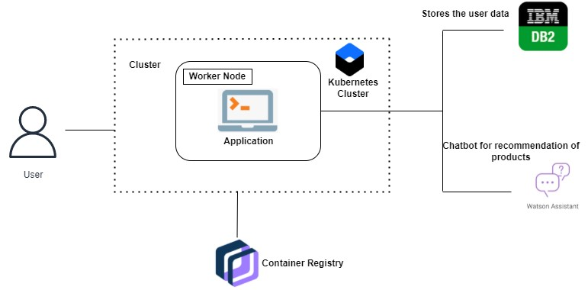

**Components & Technologies:**

|  |  |  |  |
| --- | --- | --- | --- |
| **S. No** | **Component** | **Description** | **Technology** |
| 1. | User Interface | The Customer/ user interacts with the application through chatbot. | HTML, CSS, JavaScript / Angular Js / React Js etc. |
| 2. | Application Logic-1 | The Customer will register and login to the website. | Javascript |
| 3. | Application Logic-2 | The Customer can sign In via Google, LinkedIn, Facebook etc. | Javascript |
| 4. | Cloud Database | The User data and products data will be stored in IBM cloud storage. | IBM DB2, IBM Cloudant etc. |
| 5. | File Storage | The product details like price, quantity, and other details etc will be available in cloud bucket. | IBM Block Storage or Other Storage Service or Local Filesystem |
| 6. | Infrastructure (Server / Cloud) | Application Deployment on Local System / Cloud | Local, Cloud Foundry, Kubernetes, etc. |

**Application Characteristics:**

|  |  |  |  |
| --- | --- | --- | --- |
| **S.No** | **Characteristics** | **Description** | **Technology** |
| 1. | Open-Source Frameworks | For Chatbot interaction , Watson Assistant is used.  And API is used to fetch data from cloud database. | Watson assistant |
| 2. | Security Implementations | All user data and product data will be stored in IBM cloud automatically which unknown person cannot be fetched. | IBM DB2 |
| 3. | Scalable Architecture | Micro-services architecture will be used for | java |
| **S.No** | **Characteristics** | **Description** | **Technology** |
| 4. | Availability | Application will be available 24/7. | IBM DB2 |
| 5. | Performance | To handle high traffic, we set up load balancer with multiple instances. | Auto scaling on cloud server |